Elementor - Light GDD

## – By Miguel Bermudo Bayo

# Introduction:

“Elementor” is a simple MEGAMAN inspired platformer game where your objective is to complete all levels in whatever order you choose. It is meant to be completed in one sitting as it will not save your progress.

Every level you complete will reward you with a modification to your abilities, for example a double jump, a dash, a grapple hook, different weapon shots, etc.

With a total of 4 basic levels and a final **unlockable** one. you can choose which order you want to play them, and every level has alternate routes you can take if you have abilities at your disposal, these alternate routes contain keys that will give handy power ups and consumables as well as the possibility of unlocking the extra ending (if u complete all levels fully) for the final level, where you need to use all the abilities you’ve gathered to beat it.

If the player dies, they must start the game from the beginning without any ability unlocked, so the game must be completable relatively fast.

## Motivation:

The game is a lighthearted but somewhat difficult experience too keep the player invested in the gameplay, its replayability value comes from the possibility of playing the same level twice but being able to experience it in a multitude of ways since you don’t have all abilities from the beginning.

## Mechanics:

### Basic mechanics:

At the beginning of the game the player will be able to move and jump once before touching the floor again and perform a melee attack that pushes them back a bit, the enemies will be increased in difficulty the harder the route you take is from just moving around to melee attacking to shooting bouncing laser attacks.

### Unlockable mechanics:

Each of the levels will give one the following abilities (at random as to give more replay value to the game, but a set mode should be available too if time allows it.):

* Double Jump
* Dash (ground and aerial)
* Bomb attack (lobs a bomb forward a short way, needs consumables to be used, gets 5 upon pickup)
* Spike shield (does damage, makes you immune while it lasts, short recharge timer (2-3 seconds)

## Artstyle:

The idea of the game is to have 4 very distinct levels, to maintain a cohesive sensation throughout the games flow I believe pixel art or hand-drawn assets would be particularly beneficial as well as using some light shaders to enhance the visuals of each section would provide the best experience for the players as we don’t want to overload the levels visually.

The focus is mainly to create futuresque levels that use lots of color contrast but maintain a cohesive palette between then so in the last level we can combine them all.

We can use a clean white/blue pallete to show the “good” part of town like in this image:

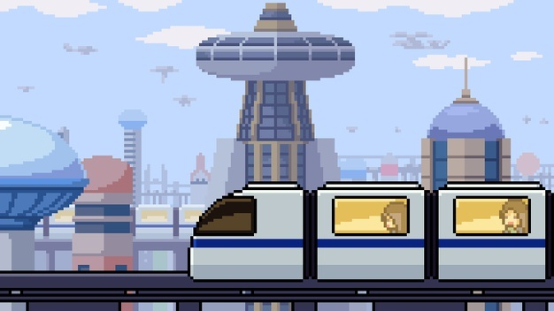

Then use a greener tone for the commercial night time district like so:

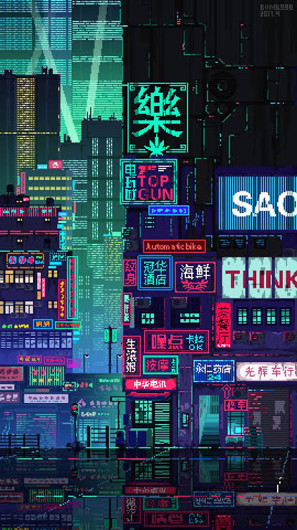

We can then go to the more “risqué” side of the city with a purple and red pallete

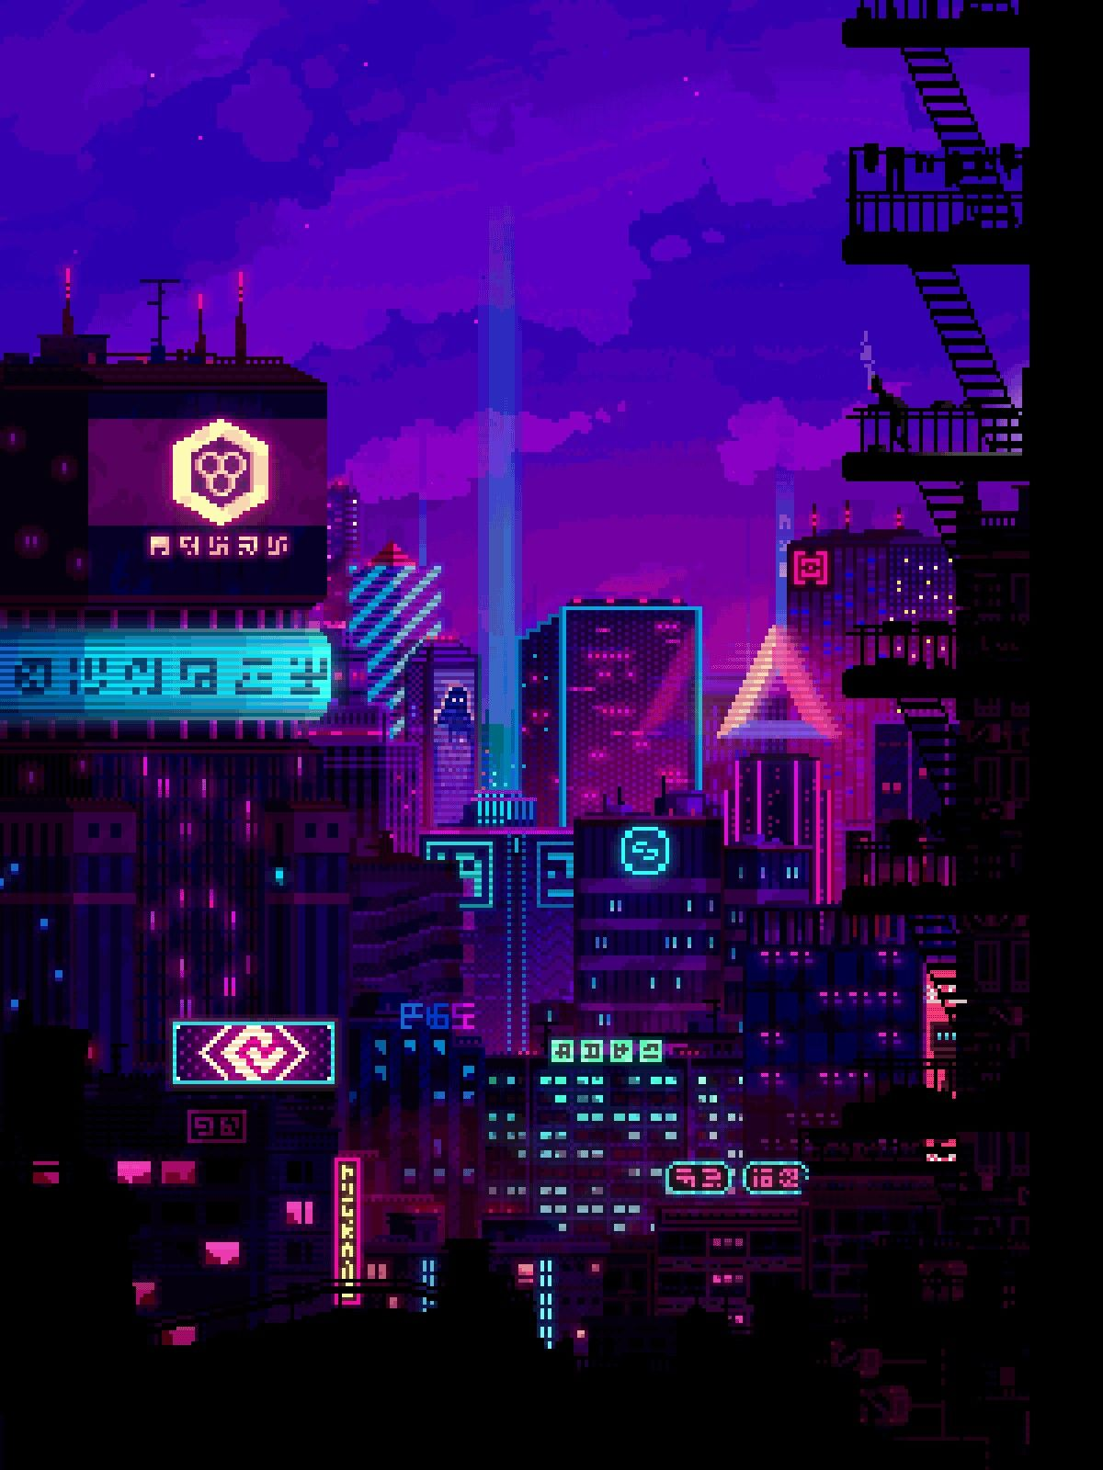

And finally, a grey and yellow neon palette that reflects the dangerous side.

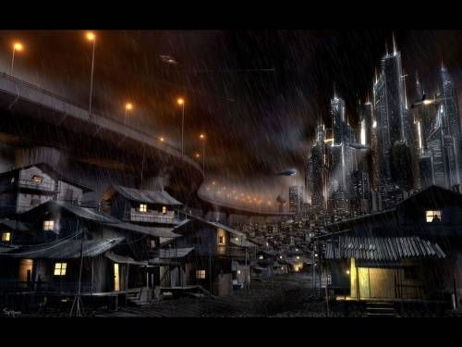

The final level would be a combination of all of the above respecting the enemies’ themes etc.

## General level structure:

There would be